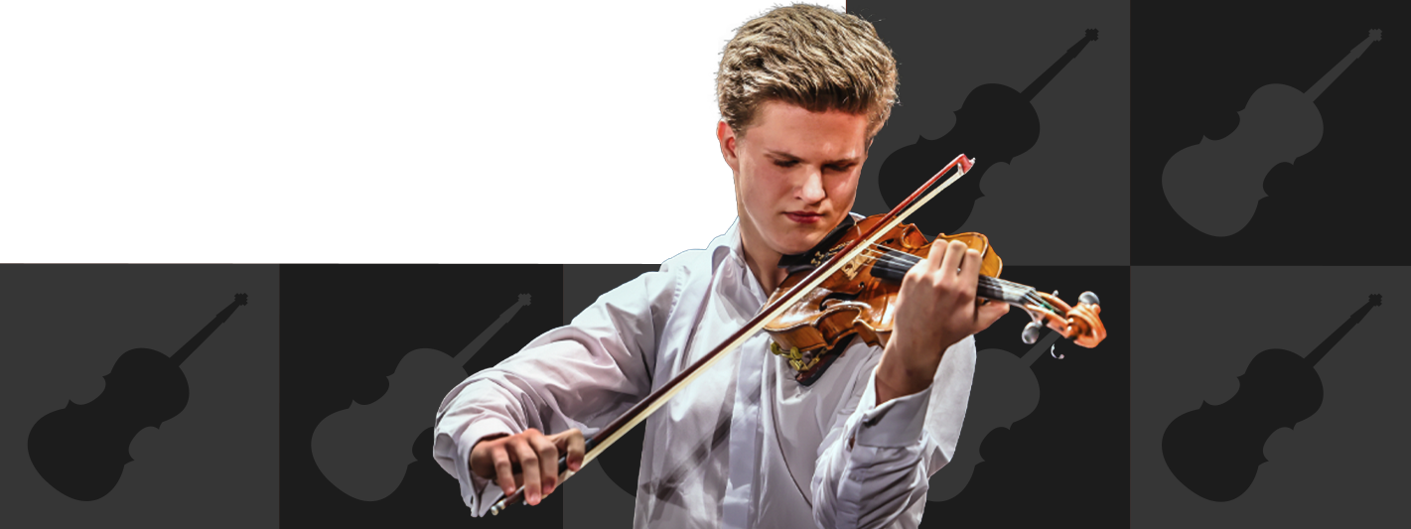

Binding application for Jiří Fišer´s MasterClass - active participant

The MasterClass will take place on the 2nd of May 2024 from 2 pm till
6 pm in the concert hall of the Jaroslav Kocian Music School in Ústí nad Orlicí. Each student gets about 40 minutes with Mr. Fišer.

Please fill in the form and send electronically before the 24th of April 2024 to the following address: info@kocianovo-usti.com

Name and Surname: …...........................................................................................
e-mail: ….................................................................................................................
Age: .......................................................

Please, list the pieces you would like to go through
Composer: …...................................... Song name: ...............................................
Composer: …....................................... Song name: ...............................................
Composer: …....................................... Song name: ...............................................

Optional note for the organisers:
…...............................................................................................................................................................................................................................................

